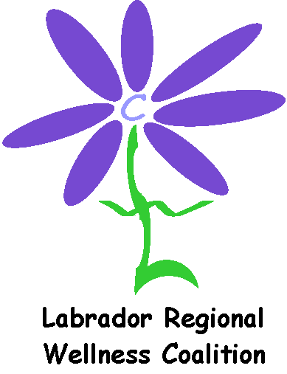
Discretionary Fund Request Form

General Guidelines:
The Discretionary Fund is used to support Wellness projects that may not need a full grant. The guidelines used for our Grant Application still apply to this fund, including the types of items that can be purchased with these funds.

Please ensure that you are purchasing healthy food items and/or items that promote a healthier lifestyle, for example: fruit, water, skipping ropes, reflective outerwear, etc. We are promoting Wellness and with wellness comes the healthier choices.

Please complete the following form and return to info@lrwc.ca .
Amount available: maximum of $100.00.
NEW: If approved, you will get an approval email. You must submit the receipts and LRWC will reimburse you the $100.00.
If you require more funding please visit our website and learn more about our community grants program. www.lrwc.ca

Name:
Organization to be listed on the check:

Address:

Email address:

What would you like to do?:

Amount requested: $

Once your event is completed please forward all receipts and photos (if available) to:
Chair LRWC
P.O. Box 7000 Stn C, Happy Valley-Goose Bay, NL A0P 1C0
info@lrwc.ca

_____________________________ _______________________ Signature Date

--------------------------------------------------------------------------------------------
For Office Use only:

Approved by: ___________________________ Amount Approved: ___________

Date Approved: _________________

