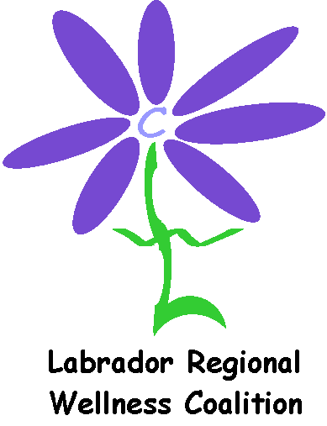 Application for Travel Subsidy 2018

Name: ___ _________________________________________
Organization: ______________________________________
Community: _______________________________________
Contact Information: _____________________________________________

Please describe your involvement in the LRWC:

Why do you want to attend this conference? How will the information be used once you go back to your community?

Please choose what you are requesting a subsidy for, give an estimate of the cost, and indicate if your organization/business is helping to cover any costs:

 | Cost: | Covered By:
Flight
Meals (Provincial per diems)
Hotel
OR Private accom ($25/night)
TOTAL

Please submit applications electronically to LRWC by May 2nd to info@lrwc.ca

*NEW* LRWC Travel Guidelines

The Labrador Regional Wellness Coalition (LRWC) has a limited amount of funding available for travel to the AGM/Workshop. Please read the guidelines below before sending your travel subsidy form.

- All requests for travel subsidy will be reviewed by the Travel Review (TR) Committee. The TR Committee will advise all applicants if they are receiving funding or not within one week of the deadline.
- If there are multiple requests from a community: One person per community will be chosen, with the exception of Labrador West which will allow for two people.
- Use of ‘Private Accommodations’ is preferred, instead of a hotel.
- There is no charge for Registration for the Workshop.
- There will be no funding for Ground Transportation for anyone staying in a hotel. The hotel chosen will be walking distance to the venue of the Workshop.
- Weather delays:
- LRWC will cover one extra night in a hotel (if that is where the person is staying).
- If delay is more than one night, LRWC will pay for ‘Private Accommodation’ only.
- Per Diems will be covered.
- The TR Committee will consist of the two co-chairs and at least two others.

Form Updated: February 2018

