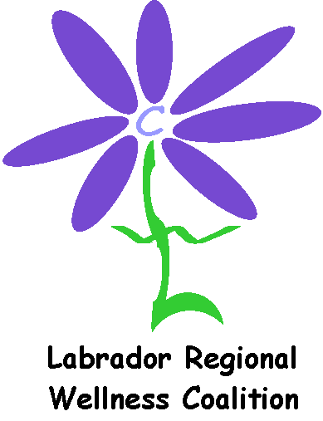
Updated: June 2018

Project Reporting Form
Community Grants Program
SUMMARY
Date of Project: |  |  | Your Name:
Project Name: |  |  | Telephone
Location of Project: |  |  | Address:
Project Description:

Number of participants in attendance at event (if applicable): _________________
Please check all boxes that apply and complete the information requested
Wellness Theme |  | ❑ Healthy Eating |  | ❑ Tobacco Control
 |  | ❑ Physical Activity |  | ❑ Health and Literacy
 |  | ❑ Mental Health |  | ❑ Child and Youth Development
 |  | ❑ Injury Prevention |  | ❑ Healthy Environments
Whose idea was it? |  | ❑ Wellness Coalition |  | ❑ Health Staff | ❑ Community Group
 |  | ❑ Other
Who Participated? |  | ❑ Children |  | ❑ Youth | ❑ Adults
 | ❑ Seniors |  |  | ❑ Other
How did you let people know?
 |  | ❑ Radio |  | ❑ Church Bulletin | ❑ Newspaper
 |  | - Other ______________

PARTNERSHIPS
A. What partners did you work with for this project?

- What did each partner do to support the project?

SUSTAINABILITY
- What plans do you have to continue your project?

- How will you let others know that you accomplished your project?

- What difference have you noticed in your community as a result of your project?

- What would you do differently next time?

COMMUNICATION
- How did you find out about the Community Grants Program?

❑ Website | ❑ Newspaper |  | ❑ Health Care Worker
❑ Community Event | ❑ Brochure / Poster |  | ❑ Community Channel/Radio
❑ Community Group or Friend | ❑ Other ______________________________________
- What kind of support did you receive from the Coalition to carry out the project? (e.g. promotional items, being available, answering questions)

- Was the Coalition clear about what was expected of you? ___________________
Promotion of Coalition as a partner  Yes  No |  | Use of funds  Yes  No
Promotion of Healthy messages  Yes  No |  | Reporting and Receipts  Yes  No

Comments:

PROCESS
- Was the grant application easy to complete?  Yes  No
If “No”, let us know how we can make it easier?

The current deadlines for grants are (Jan 1, Apr 1, Jul 1, Oct 1). Do these dates work for you?  Yes  No
If “No”, please comment

- Did you receive your grant money in time?  Yes  No
- Did we give you enough time after your project to send in your receipts and this report?
❑ Yes  No

SUCCESSES
Please share any stories or experiences from your event/project.

FINAL COMMENTS
- Can we share your project experiences with other groups?

- Was the final report easy to complete? If not, how can we make it easier?

- What final, overall comments do you have about your experiences with the Community Grants Programs?

FUNDS REMAINING
If you have more than $50 remaining, please return the unused funds. The check should be made out to:
Labrador Regional Wellness Coalition
c/o Labrador Grenfell Health
P.O. Box 7000, Stn. C
Goose Bay, NL
A0P 1C0

Please send completed form to:

Community Grants Coordinator, LRWC
grants@lrwc.ca
Fax: 896-2726

Thank you very much

